Brand = delivery / promise

Deciding your marketing focus should not be that difficult
I love simple ideas. Especially the ones that make complex subjects easy to understand. Because we only control what we understand. May simple ideas lack depth and detail but they still are robust enough to give us clarity and focus. The following is a simple idea about what a brand is. I came across it while waited to meet our CEO. This writing is barely more than a reflection on my original scribble still ready for discussion.
Brands live in our minds. They are constructs of our beliefs and experiences about them. Our beliefs are based on what we heard and experienced about a brand before. They are the internalisation of all the marketing’s explicit and implicit promises. This is what we expect to experience next time we meet the brand. And then, when we actually meet the brand, we compare our experience, the delivery of the marketing’s promises to our pre-existing beliefs. Whatever the result of this comparison may be — confirming, exceeding or conflicting our expectations — that will be the brand for us for that moment. The promises vs the delivery.
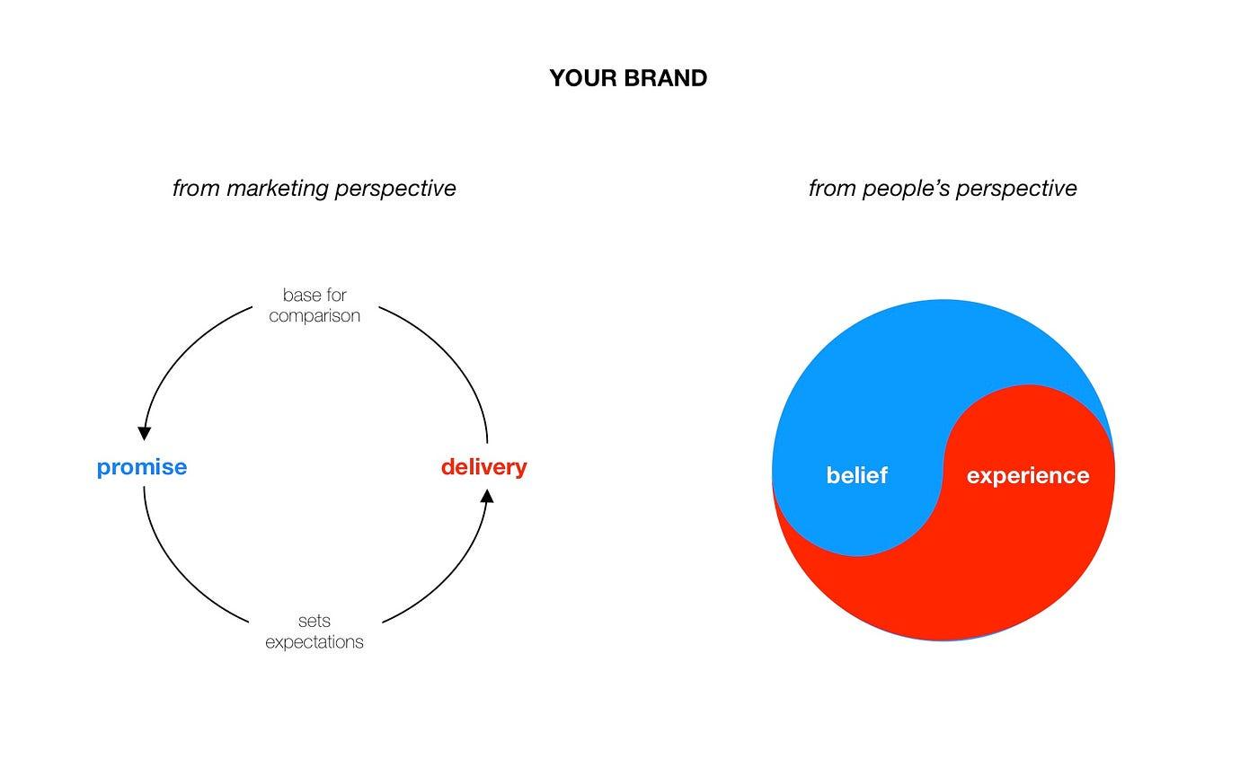
This idea suggests that your brand is ever changing with every single brand-people interaction. It also means that promises set expectations about delivery and experiences, and also correct beliefs. One will have an effect on the other regardless the marketer’s intent.
People’s individual and unconscious comparisons determine your brand. So you can understand your brand’s health by a simple division: it is the ratio of its delivery and promise. To be precise, the sum of all the beliefs and all the experiences of your entire market.
Simple?
Well, we will tell you where your marketing should focus at least:
- Do you over-promise (or under-deliver, if you will)? Give your product or service a decent boost.
- Should we just say to do what you already do well to do it a bit braver and louder? Do so.
- Do you exactly walk your talk? Well, it will change soon, so you better ‘walk faster and nicer’.
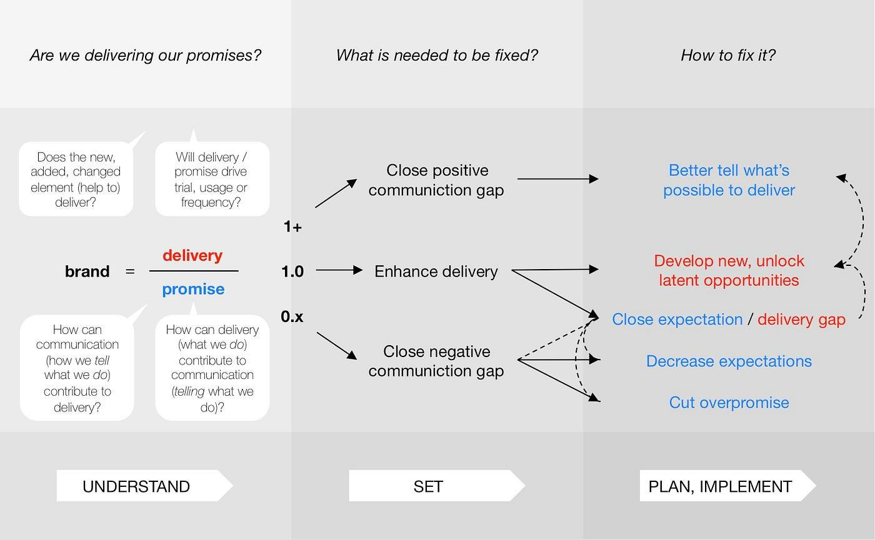
OK, see the details of the three different cases.

Closing a positive communication gap
If your brand’s delivery exceeds its promise their dividend will be over one. This result suggests that you have a positive communication gap. You can close this gap by telling better what is possible to deliver. Telling it to more people, telling it braver and clearer. The answer to your problem lays in communication.

Enhancing delivery
If you deliver exactly what you promise your score will be one. This may suggest you reached perfect harmony. But things do not stay still unless they are dead. Stay prosperous, and thus be able to control changes you yourself have to change. It is time to develop new or unlock latent opportunities in your offer and in the way your consumers experience it. Product and service design will help you there.

Closing a negative communication gap
When your brand’s promise exceeds its delivery your score goes below one. This signals that you are over-promising. You either simply stop it and start a more realistic communication or you start decrease the expectations of your consumers. Beyond communication means you can close this gap by product or service development.
So what is the delivery / promise ratio of your brand? Should you better tell what’s possible to deliver or your offer needs some polishing?
Life is just way more complex than that? And where should the numbers to the calculus come anyway? Let’s discuss and find the answer together. Just keep it simple.
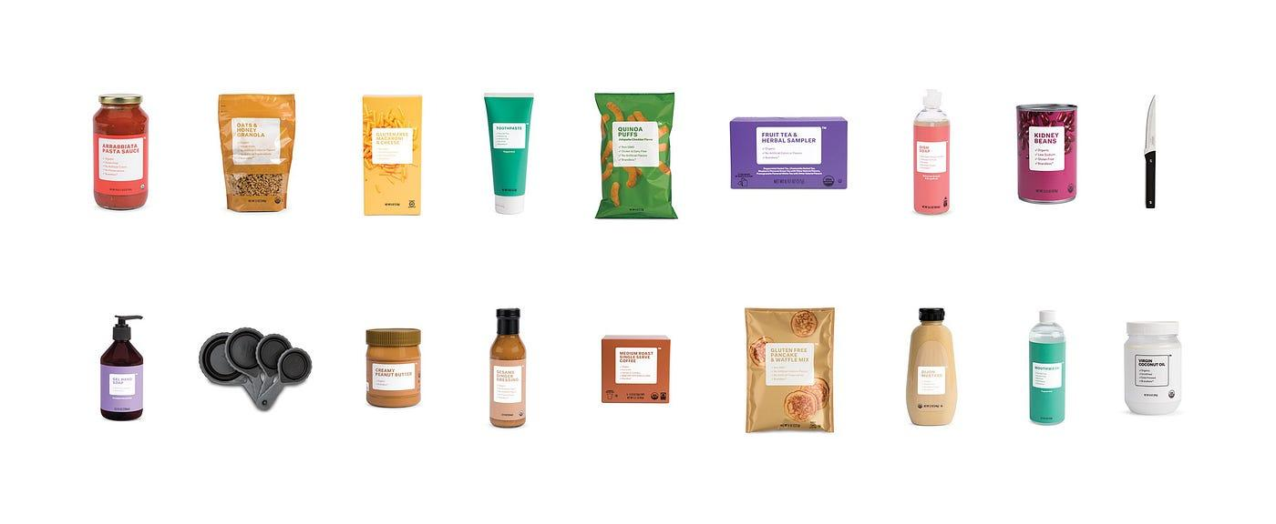

Brandless is actually a very clever BRAND​
Brandless a trademarked ‘no-brand’ offers a wide range of CPG product under the ‘no-name’, Brandless. For the first look, it’s like a non-marketed non-brand. But, hey their no-logo IS a LOGO. Brandless has a well thought out value proposition that differentiates it from the competition in a very meaningful way. It has a personality of simple, straightforward and honest. So, in technical terms, Brandless IS a BRAND.
The moral for the rest of the branded brands? Well, not to go brandless … should they all go brandless would make it, well meaningless. To Brandless, too. But to cut the ‘brand tax’ by skipping the traditional trade altogether and go directly to customers is the thing to consider. Especially it means a single, 3USD price for all quality product.
Do you remember Anything or Whatever, the Singaporean soft drink for the undefined? Or Help remedies, the single ingredient generics with a very human touch, take less? There is always room for rebels, as long as the rest of the pack moves slowly and carefully.

Products too are mediums

Products mediate between people and companies, the way mediums do between their audiences and performers . So media agencies, who excel in orchestrating relationships via mediated interactions should go beyond campaign optimisation.
What follows is a thought experiment. A ‘Shitty First Draft’ of a flash of an idea. I share it in the hope to get your honest critique or contribution. Thanks for reading it anyway.
Mediums mediate between two parties. Standing in-between, they convey an intended message from one end to the other, and the reaction back to the sender. In the form of repeated interaction or a dialogue, a relationship emerges. Every interaction facilitated through the medium, shapes this relationship.
In this sense products and services too are mediums. Their producers’ or providers’ intent is to create value for their customers or clients. To make a positive change in their lives [message]. People find value or utility in these products or services so they purchase them [reply]. In case of mutual interest, the exchange repeats. The dialogue continues, a relationship emerges.
So companies’ output is not an end itself, but a mean to an end. They don’t produce for the sake of the production. Their product is a medium.
If this is the case, then media agencies have the knowledge, and the resources to deal with more than ‘just’ campaign optimisation. The way they orchestrate the channel mix, and the TRPs in the light of the expected outcome, within the given budget could be applied to other fields of the business as well. How many times, how often and in what ways should a brand meet its audience via their product [being a medium] to maximise their relationship. I think media agencies are not in the business of advertising logistics, but in the business of brand-people conversations regardless of the medium.

Brand architecture in practice
It’s almost a no-brainer what model to use when developing a brand architecture. The trinity of the branded house — endorsed brands — house of brands is the obvious answer. It is easy to formulate arguments for and against the three basic types of brand architecture. But the reality is somehow never that simple. In principle, it is rarely possible to build a brand architecture for a company from scratch, following a crystal-clear logic. Rather, it is more common for a merger or the emergence of new entities to make it necessary to sort out the chaos of brands that have developed organically according to the ideals of successive ores, and which are stretched along the internal power lines of the company. How to develop a realistic brand architecture, not born in a vacuum, be acceptable to all stakeholders and sustainable for the future? A recent assignment forced me to find an answer to this question.
A new company was created by the merger of multiple predecessor companies with similar profiles. All companies have offered a range of products and services to several different markets. These have been rationalised from a business point of view. The main ambition was to create a system of a strong core brands and supporting sub-brands. The question was what kind of structure was needed in the newly created system of products and services. The brief we set ourselves was to provide clear guidance for all current and future branding efforts:
- which potentially brandable elements should be truly (sub)branded
- what is the appropriate relationship between the different elements to be branded
- what distinction in terms of content and form is required between the individual elements within this relationship
- how to maximise the return on branding investment by achieving the greatest possible synergy and consistency
Relevant past and competitor and professional best practices have been taken into account in the development of the scheme. However, it was not intended to replicate past practice or to take into account views beyond professional considerations and business interests.
We started the work by mapping out the entities to be placed in the brand architecture. As we did not yet know exactly what aspects of the entities we would be using when organising them, we tried to be as detailed as possible. So we tagged whether a given entity is visible outside the company or only inside the company. To which business unit it belongs. Whether it is a bulk or an individual service. Whether it serves a separate clientele or is embedded in something else. Does it carry any reputational risk for other entities or does it offer positive synergies. In what capacity the company is present in the life of a given entity: employer, owner, partner, patron … and even whether that entity is a segment, a product, or a program.
Along the lines of the above labelling, a robust structure started to emerge, but with this, we had two problems. First, it followed the internal structure of the company, which meant that it did not necessarily correspond to the reality of the external observer. Secondly, it was not possible to classify all entities into the emerging brand architecture.
Two approaches, independent of brand architectures, helped us to resolve the above problems.
One is used in service design, namely in the service blueprint. It looks at the service from the user’s point of view and distinguishes three levels. The first level is where the direct interaction between the service provider and the customer takes place, up to the so-called line of interaction. The next level is up to the line of visibility. Here are the background processes that are still visible to the customer, even if there is no direct contact with them. Finally, beyond the line of visibility, there are all the processes and actors involved in the service that the customer does not have any knowledge or impression of.
This approach has helped us to look not just at the internal workings and structure of the brand architecture, but also to consider what the ultimate stakeholder of the brand, the customer, sees and understands from all of this.
The other concept we have adapted was one that helps interpret corporate and business strategies (Martin, Roger. “Corporate Vs. Business Unit Strategy” Medium, 24 Oct. 2022, medium.com/@rogermartin/corporate-vs-business-unit-strategy-adb1163665da.) The essence of the approach is that — in complex systems such as a corporation operating in many business units with multiple offer brands per business unit — it distinguishes between the invisible and the aggregate strategy. The invisible — or in my interpretation elementary — strategy emerges where it is no longer possible, or makes no sense, to further decompose the strategy (e.g. P&G / Beauty / Shampoo / Head&Shoulders). This is the basis of the strategy. By combining these invisible, elementary strategies at a higher level, the so-called aggregated strategies are created. When combined, they represent a higher value of the aggregated elementary strategies included. It makes sense and is useful to aggregate elementary strategies as long as the additional cost of doing so is worthwhile and generates additional benefits.
The concept of aggregates in a different approach has helped us to consider in further thought through brand architecture — instead of slavishly mapping the internal structure of the company — where it makes sense to fatten the level of the elementary brand entities or to consider the rationale for aggregating them at a higher level.
Taking the above into account, the following brand architecture logic has been developed, which can be applied to similarly complex situations in the future.
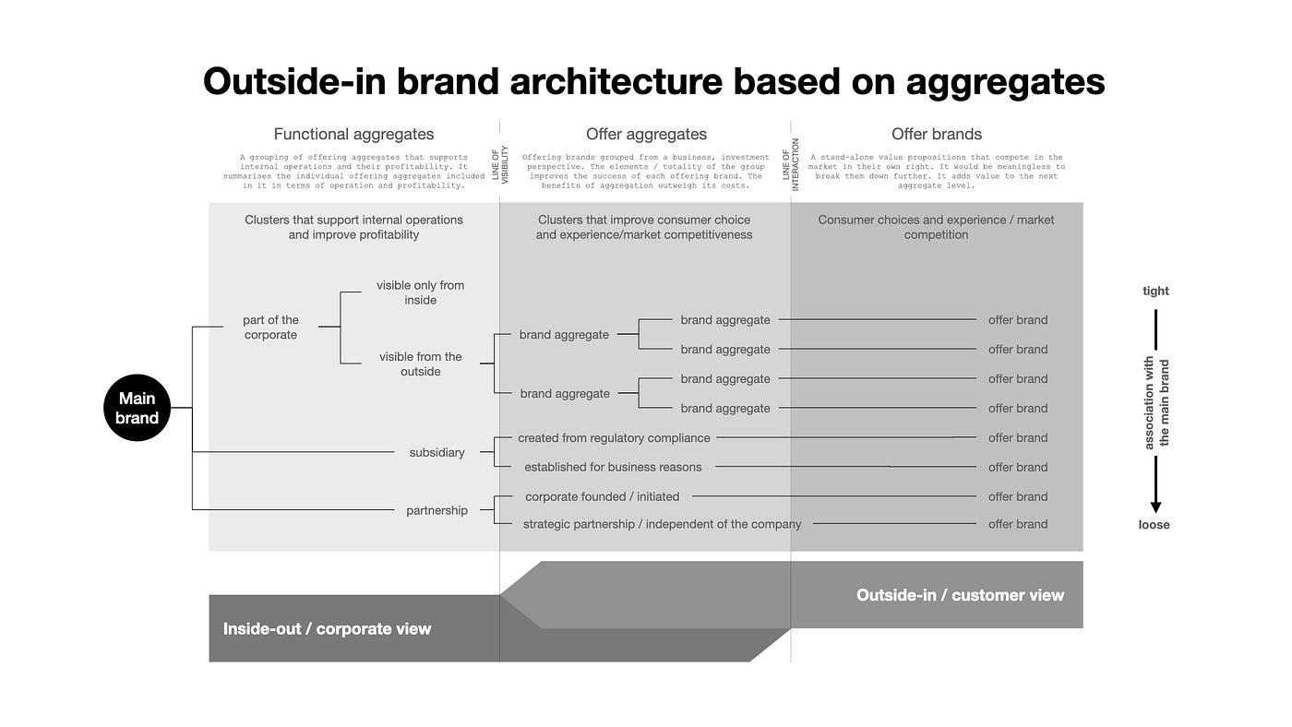
A brand architecture model combining Service Design’s ouside-in perspective and the Aggregation Strategy
In the horizontal direction, moving from the outside (left to right in the figure), the offer brands appear first. From the consumer’s point of view, this level goes up to the interaction line. This is where the basic consumer decisions and experiences are made, and where the clearest market competition takes place. The offer brands classified here are all self-contained value propositions that compete in the marketplace in their own right. There is no point in further disaggregating them from a brand perspective. And all add value to the next aggregate level.
The second (middle in the figure) level is the offer aggregates. Here we have clusters that improve consumer choice and experience and market competitiveness. That is clusters of offer brands from a business, and investment perspective. The elements of the cluster, and the aggregate, improve the success of each offer brand. The benefits of aggregation outweigh its effective costs and the costs of inflexibility.
Finally, the innermost (left) level is that of functional aggregates. That is clusters that support internal operations and improve profitability, into which the bidding aggregates are grouped. It brings together the individual offer aggregates included in it in terms of function and profitability.
Looking vertically, another dimension of the brand architecture emerges. Here, from top to bottom, we distinguish between the aggregates and the offer entities that are decomposed from them according to their proximity to the core brand, i.e. the company. At the top level are those entities that are an integral part of the company/core brand. They speak either to the outside world or to internal operations. These are the entities whose image and values differ only to the minimum extent necessary from that of the core brand.
The next level is the subsidiaries. Here we have distinguished subsidiaries that are not organised for internal, business reasons, but for external, regulatory compliance. As in the previous level, these also remained close to the parent brand. One step further away were those entities that were organised for explicit business reasons. This was also reflected in their image, which could be different from the core brand in terms of their valuation.
Finally, the entities furthest away from the core brand were the various partnerships. Here, as with the subsidiaries, we distinguished those that were more important to the company from those that were less important. Partnerships that were formed or initiated by the company itself were more indicative of the parent brand, while those that were independent of the company were only loosely indicative.
Although there was a logical and strong internal drive to develop a brand architecture that followed the internal structure of the company, it was still possible to take an outside-in view and classify all existing and future entities with confidence.

Discover the future of branding

A journey through time and possibility
‘The Future of Branding’ — image by Dall E using the prompt: utopian cityscape with futuristic brand signs in hyperrealistic style
In this article, I delve into the evolution of branding and examine the different factors that have shaped its concept over time. From its early days as a means of identification to its current role as a source of connection and meaning, explore what the future might hold for branding. Gain insights into the impact of technology, changing social norms and cultural values, and the role branding will play in shaping our future. With thought-provoking questions and a deep dive into three distinct scenarios — conservative, realist, and extreme — join me in thinking about the future of branding.
Although I’ve been developing brands for over twenty years, it was only now, when I was asked to do so, that I started to think more seriously about the possible future of branding. At the end of a training course, I was asked, along with other market experts, to consult with students. One of the topics they were interested in was the future of branding. The following thought process helped me to prepare.
In order to think about the future of branding in a meaningful way, it is worth clarifying some basic questions. What do we mean by brand? Why do brands exist? How has the concept and practice of branding evolved? What influenced its evolution and what has influenced the practice of branding? What are the implications for the future of branding? Let’s see them one by one.

What do we mean by brand?
In practical terms, a brand is the set of impressions that people have of a company, product or service, and which evolves as they are exposed to new impressions. In other words, it is the impression of the brand owner’s intentions and the independent influences that have a significant impact on the brand image. These may be the direct personal experiences of the person concerned or the experiences mediated by others.
In a business approach, the brand is the ultimate difference that engages people over the long term.

Why do brands exist?
On one hand, because the brand owner hopes to gain a financial benefit, some kind of competitive advantage. By branding, he wants to emphasise, attract and remember the advantages of his company, product or service. In addition to, or even in its absence of, it adds additional meaning to its product that makes it more attractive to the consumer. Hoping this will result in a price premium and/or lasting customer loyalty.
On the other hand, brands can exist because they meet basic human needs. We feel we can relate to them. We can find pleasure in them, they can give us a sense of freedom of choice. We can identify ourselves with its values, its goals, and experience a sense of belonging. We can define and express our identity through them. They can therefore carry extra meaning we want.

How has the role and concept of brand evolved?
It is not my aim to explore the concept of brand and the practice of branding over time in an academic manner. In the literature I have used, I list some of the writings that attempt to do so. However, I consider it is important to outline how thinking about brands has developed and enriched, and how the new components of branding have emerged in succession. By looking at it in perspective, it is easier to reflect on what has been and what is evolving and what new elements might enrich our understanding and practice of branding in the future.

Trademark = identifiability
Initially, the sole aim of branding was to identify products. Trademarks make it easy and clear to identify the product and its manufacturer, even to the illiterate. Trademarks remain the most elemental brand ingredient, but, according to the Google Books Ngram Viewer, their mention in English-language books has fallen sharply since the mid-1990s.
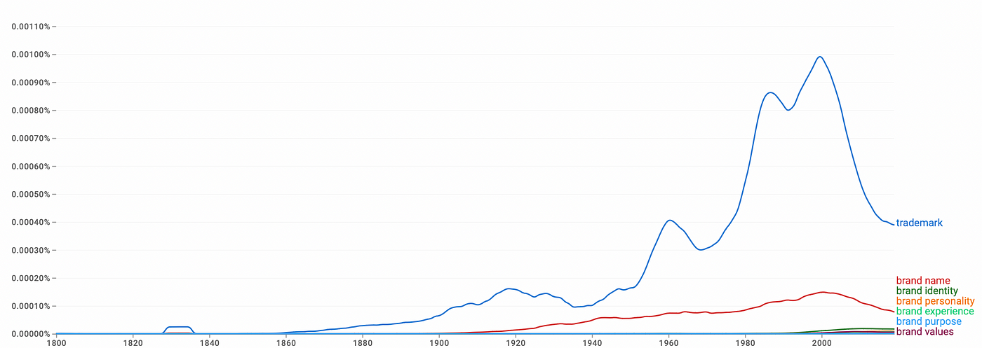
Google Books Ngram Viewer of the phrases ‘trademark, brand name, brand identity, brand personality, brand experience, brand values, brand purpose’ in Eglish litriture between 1800 and 2019

Brand name = guarantee
The next, a distinguished trademark if you will, is the brand name. Initially, it was typically the same as the manufacturer’s family name, giving the customer a personal guarantee. More recently and increasingly, the brand name alone does not carry the personal guarantee of a specific individual, especially as this naming practice is disappearing. The brand name is still the defining brand ingredient, but, like trademarks, it has become less and less talked about over the last three decades.

Brand image = (visual) differentiation
The boom in mass production and consumption after the Second World War required businesses to differentiate their products from a growing number of competitors. Standing in front of the shelf, it had to be clear which box consumers should reach for. With the advent of audiovisual media, globalisation and the internet, the need for a distinctive image has increased. However, in the last few years, this trend seems to have come to a halt and there has been a slight decline in the frequency with which brand identity is mentioned.

Brand personality and values = relation and connection
As a continuation of the practice of branding with character, it has become increasingly important to infuse the brand with content and meaning that is derived from, but goes beyond, the product being branded. The means of doing so are the values associated with the brand, and in many cases represented in a meaningful way, and the personality traits that are at least consistently represented in its communication. By adding these two elements, a link or relationship — going beyond the product or service — could be established between brands and their consumers. After all, if brands can have a personality and values, it follows that people can also develop a relationship with them and even formulate expectations of them.
As with brand name and image, personality and values have recently reached their peak and their importance in terms of the number of mentions has diminished.

Brand experience = choreographed experience, planned memories
The first next generation brand component emerged in branding theory and practice in the late 1990s and early 2000s as a method for understanding, measuring, influencing and consciously shaping consumers’ emotional and sensory connections to brands. The concept developed in response to the growing recognition that traditional methods of measuring brand equity, such as brand familiarity and brand loyalty, are insufficient to fully capture the complex relationship between consumers and brands. The development of brand experience has also been influenced by the rise of experiential marketing and the increasing importance of creating unique and memorable brand experiences as an additional means of differentiation.
In addition, the growth of digital technologies and social media has made it easier for consumers to share and compare brand experiences, further emphasising the importance of creating positive brand experiences.

Value-driven brand, brand activism = community of practice, collaboration
Although corporate social responsibility has been an established practice for nearly fifty years, value-driven brands [purpose] and brand activism have only been spreading in the last decade or two. The emergence of this concept has been driven by a growing awareness of the negative impacts of business on society and the environment. Consumers have increasingly expected companies to take responsibility for their actions and contribute to the common good. Businesses also began to recognise that aligning their activities with social and environmental values could build stronger, more positive relationships with their customers and communities. As a result, the concept of a values-driven brand is gaining ground, enabling companies to position themselves as responsible and ethical actors in the marketplace.
Brand activism has gained momentum in the last decade as consumers have taken a more active role in shaping the brands they interact with and as companies have recognised the benefits of aligning their values with those of their customers. Some of the main drivers of this trend are increased awareness of social and environmental issues, the rise of social media and the growing influence of consumer advocacy groups.
By reviewing how the concept and practice of branding has changed shows that the role of the consumer has also evolved. From being a customer to be targeted and won over, they have become potential partners, fans and more recently, fellow companion and co-creators. Who knows, next they will become the real owners of brands.
Consumers’ expectations of brands have also changed. Today’s consumers expect more than functional, emotional and persuasive things from a brand. They care about how the brand “behaves”, what it does to be relevant to them, how it helps them achieve their goals.

What has influenced and been influenced by the practice of branding?

Modern, postmodern and metamodern influences
The general perception of modernism has also appeared in the contemporary understanding of brands, which is owner-centric, reductionist, rational consumerist and passive. The brand was thus conceived as something that was entirely under the control of its owner, and the individual brand components were considered and developed in isolation from each other for the rationally minded consumer. Marketers treated it as an inanimate, passive entity that could be interpreted from the outside, with no independent life to do things with.
Postmodernism, which emerged in the 1960s and 1970s, rejected the idea of a single ‘truth’ in its general cynical ambivalence and instead celebrated diversity and plurality.
Postmodernism also had room for thinking beyond rationality, so that brands were expanded in this era to include symbolic values beyond functionality, associated with the product through the brand. As consumers increasingly chose brands for their added meaning beyond functional benefits. In the postmodern conception of marketing, the brand is now a living entity, a subject to be understood from within.
Metamodernism, which emerged at the beginning of the 21st century, combines elements of modernism and postmodernism, moving from one to the other as a pendulum. It emphasises the importance of honesty and authenticity, and focuses on branding that is emotionally relatable and resonant for consumers.
Brands’ mission and values must be fully aligned with those of the company and its employees. In this way, they are no longer just well-chosen words, but guiding principles that translates into everyday decisions. The outward expression of the macaque is the same as the inner experience and the consumer experience. Thus the brand goes from being a unilateral instrument of influence by the owner to a common cause for all concerned.
Moreover, these principles are not ideas that are eternally engraved, but organic systems that evolve with the environment and culture.

The impact of technology on branding
In the past, brand building was mainly based on word of mouth and personal promotion, but with the invention of the printing press, brands were now able to advertise and promote themselves through printed materials to the broader audiences. With the advent of the industrial revolution, mass production techniques enabled brands to produce products at lower cost and reach a larger audience. The spread of radio and television allowed brands to advertise to an even larger audience and build brand loyalty through consistent messages. The advent of the internet and social media has further changed the interaction between brands and consumers, allowing for more personalised and interactive branding strategies. Today, technologies such as artificial intelligence and machine learning are also being used to increase the effectiveness of brand campaigns by analysing consumer data and providing insights.

The negative effects of branding
Branding can fuel over-consumption, which can lead to waste and contribute to social and environmental problems.
Brands can contribute to cultural homogenisation, as multinational companies often promote similar products and lifestyles in different cultures.
Branding can therefore exacerbate social and economic inequality, as companies often target their products and services at higher-income consumers while neglecting lower-income ones.
Branding should focus on transparency, credibility and social responsibility. Companies must be transparent about their business practices, production methods and supply chains. They must be credible in their messages and actions and take responsibility for the negative impacts of their products or services on society or the environment. Brands must also actively work to address and repair the damage caused in the past. This can include investing in sustainable practices, supporting local communities and taking steps to reduce their carbon footprint

The positive effects of branding that should be preserved
Brands can have a positive influence on society by representing the right values and causes, building on their widespread recognition and culture-shaping capacity. They help consumers to make the right choices and to embrace and deepen these values through belonging and self-expression.
The approach outlined above can be a way for businesses to stay competitive and to disseminate their innovations widely.

Three approaches to the future of branding
If we take stock of and assess the factors that influence branding and then apply these to three fundamentally different scenarios (conservative, realist, extreme), we have a good chance of getting close to the future of brands. So let’s look at the forces that could shape this future.
Trends in technological development that affect the way branding is done, or bring about changes in the system of which branding is a part, that could have a fatal impact on branding itself. Beyond the obvious, such as the impact of artificial intelligence or augmented and virtual reality, this may include disruptive technologies that are not yet known, which could fundamentally rewrite traditional business models, market logic and the way products and services are consumed. This may transform brands as we know them today or even make them redundant.
Environmental and economic changes which, at the very least, will significantly reshape consumer society, but in extreme cases could even lead to its complete disappearance. These changes may have a direct impact — either through market logic or regulation — on the practice of branding as we know it today, or on its very existence.
Changes in social norms and cultural values may also lead to significant changes in consumer behaviour in response to these influences. Sustainability may become more important than consumer needs and choices, and personal values more important than corporate needs. All this must necessarily be reflected in branding practices.
As I am not undertaking a full-fledged scenario analysis here and now, I will not examine how complete and accurate the above list of factors is, nor which of these may have the most unpredictable impact on the future of branding. However, it is still worth taking stock of how the three baseline scenarios portray the future of branding.

Conservative scenario: brands evolve organically
On the technology side, the increased use of data and analytics could lead to more personalisation, leading to fully customised brands. However, the usefulness of this is challenged by the very nature of brands as a way for people to experience a sense of belonging and self-expression. If a given product has different additional meanings for different consumers, it means nothing to anyone.
At the same time, brands can put more emphasis on creating memorable experiences through the appropriate use of augmented and virtual reality. Thus, the greater use of experiential branding, more experiential forms of communication such as events or customer interactions, can be a key differentiator for brands.
There are already good practices in place to integrate environmental and social costs into business decisions. The increased emphasis on sustainability and social responsibility and the transition to a de-growth economy will certainly be reflected in branding practices, including through government regulation.
Most likely, however, as a logical outgrowth of the now progressive value-driven and movement brand approach, brands will move from being a cost of differentiation to being the essence of business. In other words, the brand and the business have the same goals and values, and are identified with by everyone inside and outside the organisation. It is not just a message to the outside world, but also a compass for internal operations, setting a direction for product and service development. In this way, the brand becomes tangible and relevant to all stakeholders, inside and outside the organisation.
A good example of this approach is The Whole Brand Thinking approach of the Bakerly agency. In their interpretation, total, complete brands can be described by four criteria:
- The brand owner’s organisation considers everything it does as branding
- The brand provides long-term guidance for all the company’s activities
- External and internal culture, words and deeds are in perfect harmony
- The organisation measures success holistically, based on impact beyond profit — on people, community and planet
In addition, below are some thought-provoking questions to consider further in this scenario:
- Is it conceivable that trademarks, the elementary brand identifiers, will disappear first? Could the success of the American Brandless and Canadian No Name brands be a sign of this?
- Or do these examples show that branding is once again redundant in certain categories?
- How do tobacco brands still work, can they still be considered brands in the current context?

Extreme scenario: brands and branding will die out in the foreseeable future
At the other end of the spectrum, there are theories that brands and branding practices will cease to exist in the foreseeable future. Either because changes in certain factors will make brands obsolete or because we will inevitably abandon the practice of branding as a consequence of these changes. Rather than analysing these factors and their effects, I list below some questions that may help us to think more deeply about the path to a fatal outcome.
- What can lead to brands becoming irrelevant, or to the practice of branding being eradicated?
- What might cause the disappearance of the competitive economy and with it the practice of branding as one of its tools?
- What radical technological changes could make branding obsolete and redundant?
- What might change cultural and social norms to such an extent as to render the existence of brands unjustifiable?

A realistic scenario: brands will survive in the long term, but will undergo significant changes
For me, this is the most exciting approach, as it is much more unpredictable than the conservative one, but also more manageable than the extreme scenarios. It allows room for imagination, and thus even for acting out one’s own ambitions. Instead of creating an infinite number of possible futures, I will sketch out a scenario that I like, and provide further questions for anyone to create their own.
The basic question for me is: how do we need to change our branding practices, our understanding of branding, so that it can move from being a vehicle of over-consumption to a tool for sustainability?
This can be helped by reflecting on the branding practices and brand roles implied by the alternative business and economic models that already exist and will hopefully become common in the future.
One such example is the circular economy model that seeks to maximise resource use and minimise waste. This, unlike the linear economy, does not consider either the natural resources used in production or the waste left after use as an external factor. Instead, it favours reuse, repair, refurbishment and recycling, a closed supply chain, resource sharing and the use of waste as a resource.
Similar to this is the sharing economy model, which focuses on buying utility rather than the property needed to achieve it through resource sharing.
In these approaches, the brand may not be intended to stimulate consumption either. However, it can help to transform the former consumption-centred culture by making it desirable to the masses.
The B Corporation model focuses on social and environmental impacts of their operations, rather than focusing solely on profit maximisation.
They do this while adhering to voluntary standards of accountability and transparency.
Finally, social enterprise models, such as cooperatives and non-profit enterprises, for which income is a means to achieve their social or environmental mission.
Both of the above approaches assume that the brand is shaped by the control, vision and objectives of all stakeholders.
Brands will therefore have to build the idea of sustainability in the future, while giving all stakeholders an increasing say. How can this be achieved?
In my view, it is essential to replace utopias with portopias, both in terms of the vision and mission of each brand and in our concept of brands. In other words, instead of the futile pursuit of a single, but unattainable, ideal from the misery of the present, we should allow ourselves a broader interpretation of possible futures — and not only positive ones — by recognising that it is impossible to predict which future will actually come to pass.
To do so, it is necessary to accept that progress is both automatic and painful, as it creates new problems and the loss of previous values. Progress therefore involves chaotic thinking, useful errors of judgement and a sincerely ironic faith. All we strive to do is to move closer each day to an undefined better world, accepting that we must reassess each day both our destination and the next step on the road to it.
This is my idea. To help you make up your own mind, here are a few questions to consider when thinking about a realistic scenario:
- How far can the associated meaning beyond the merits be asserted when selling products and services?
- How sustainable is it to enforce this additional meaning in the form of a price premium or a long-term commitment?
- What are the failures of branding? Can they be corrected? Can branding be a cure for the problems it (partly) causes? Or can only the elimination of branding (and the system of which it is a part) be a solution?
- Can consumers take ownership of brands?
- Are we able to see beyond our blindness of a lifetime when we build a brand? Can we turn to the future of branding with transgenerational empathy? What is needed to think about alternative futures?
- What would the practice of brand building look like if it were done by nature?
I look forward to your thoughts to add to, debate or further reflect on the above.
Literature used:
Hanby, Terry. “Brands — Dead or Alive?” Market Research Society. Journal., vol. 41, no. 1, SAGE Publications, Jan. 1999, pp. 1–11. https://doi.org/10.1177/147078539904100107.
Bastos, Wilson, and Sidney J. Levy. “A History of the Concept of Branding: Practice and Theory.” Journal of Historical Research in Marketing, vol. 4, no. 3, Emerald, Aug. 2012, pp. 347–68. https://doi.org/10.1108/17557501211252934.
Young, Miles. “What Matters for the Postmodern Brand.” Market Leader, season-01 2018.
The Futur. “What Is Branding? A Deep Dive With Marty Neumeier.” YouTube, 17 Dec. 2019, www.youtube.com/watch?v=dpZfNNYUZEc.
Lee, Jordan. Metamodern Design: An Outlook on the Future of Design. Independently Published, 2020.
Galles, Tim, et al. _Scratch: How to Build a Potent Modern Brand From the Inside Out_. BARKLEY, INC., 2020.
Freinacht, Hanzi. “What’s the Difference Between Utopia, Eutopia, and Protopia?” Medium, 23 Feb. 2022, medium.com/@hanzifreinacht/protopia-beyond-utopia-8200a20b2c43.
“Barkley | Whole Brand.” _Barkley_, www.barkleyus.com/wholebrand.Accessed 7 Nov. 2022.

Brand building beyond communications

Breath life into your brand through strategic value placement
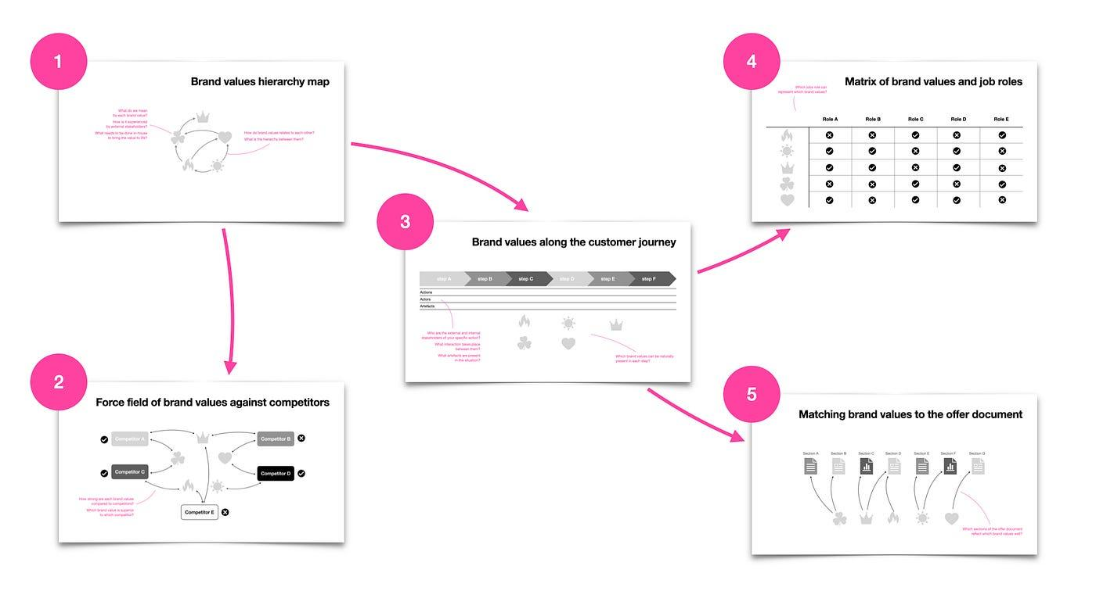
Bringing brand values to life by defining the right moments
Creating a well-defined brand is critical for the success of any business. However, achieving a clear brand definition is not always an easy task, even for talented professionals. While effective communication is important for building initial connections with potential customers, personal experience is what truly shapes their perception and image of the brand. To help this particular consulting firm build a more effective brand, a comprehensive approach was needed. Through a series of workshops and analyses, the team was able to identify their core values, align them with their customer journey, and create a unique brand equity that sets them apart from competitors. In this case study, we explore the step-by-step process that was used to help this firm achieve its brand goals.
A team of talented engineers and project managers at an IT security consulting firm came to a critical realization — their brand lacked definition. They understood that a well-defined brand could help them increase their customer base and foster loyalty among existing ones. So, like the diligent professionals they are, they immersed themselves in branding literature, hoping to find the perfect core concept and values of their brand. However, despite their best efforts, they were surprised to find that this did not bring their brand to life. That’s when they turned to me for help. While they initially thought a communications campaign would do the trick, after our first conversation, it became clear that they needed something entirely different.
If a business’s success hinges on the skills of its team and the relationships it builds with its partners, then it’s in those relationships that the brand is born. Although effective communication is vital to establish initial connections with potential customers, it’s the personal experience that shapes their perception and image of the brand more than anything else. That’s why my first suggestion was to concentrate on how their brand could be constructed through their interactions with clients before creating brand communications.
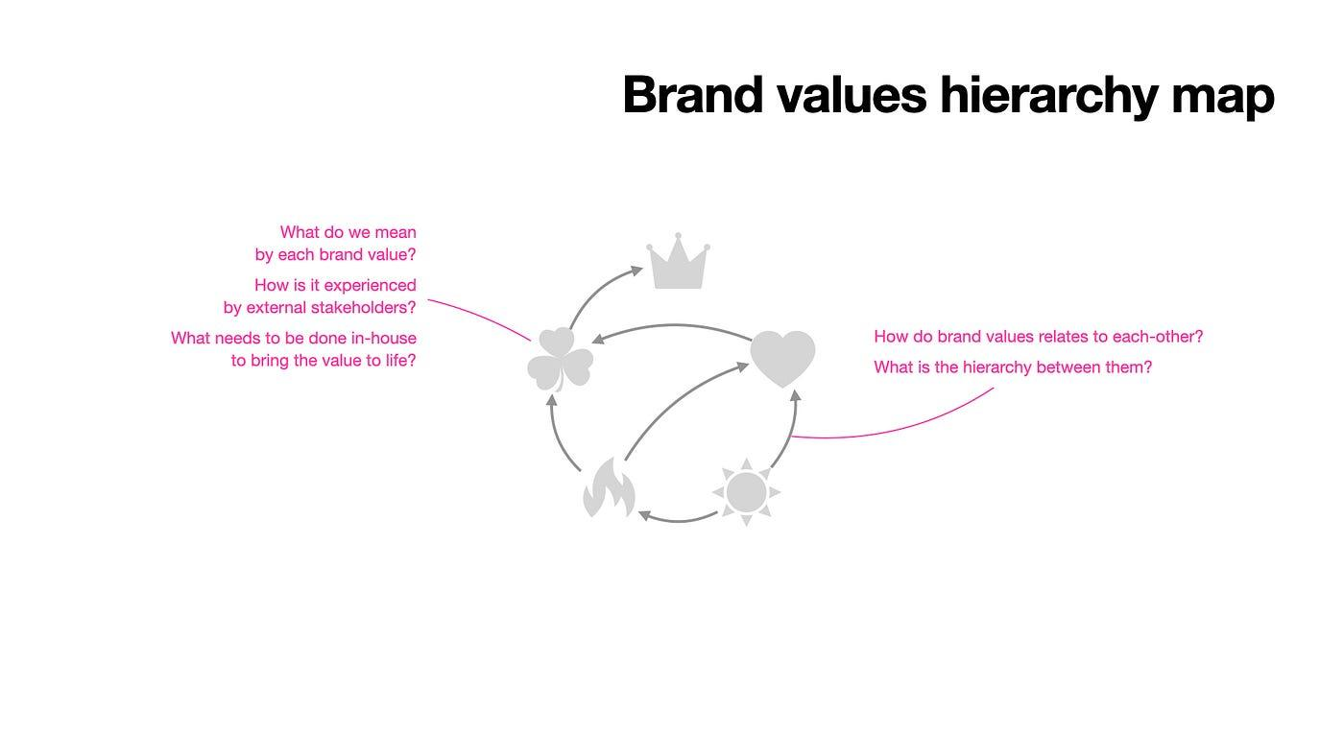
The first thing I asked the team to do was to share their brand values. During the initial workshop, they presented their interpretation of each value, how it should manifest in their customer’s experience, and what internal actions were necessary to bring it to life. From there, we analyzed how each value related to one another. This process allowed us to identify and eliminate any redundant values while also establishing a clear hierarchy of values.
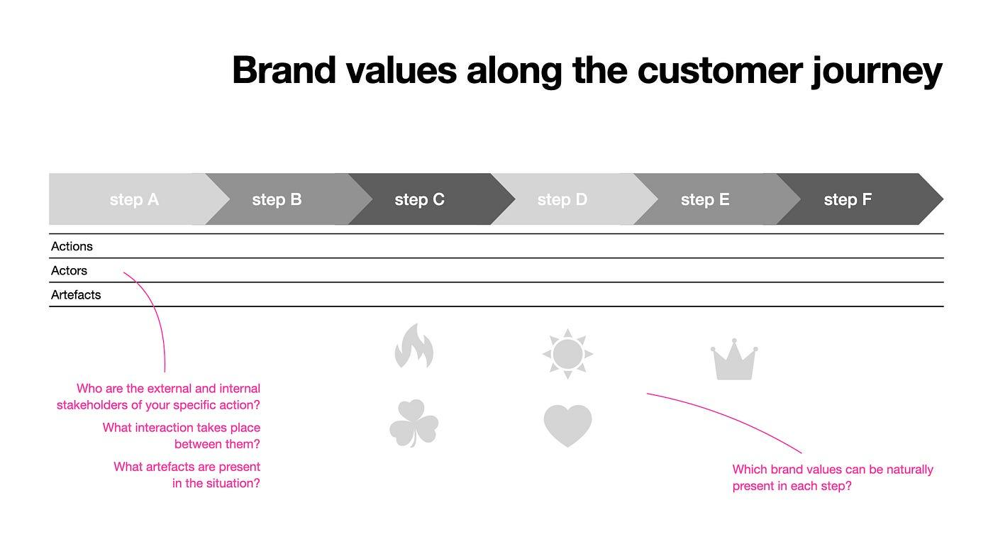
In our next workshop, we worked together to outline a typical client lifecycle, from when they first heard of the company to discuss the next opportunity after successful project completion. We then delved into each stage of the customer journey, examining the interactions and identifying the key stakeholders at play. Based on that information, we identified the brand values that have the potential to manifest themselves there in a meaningful way.
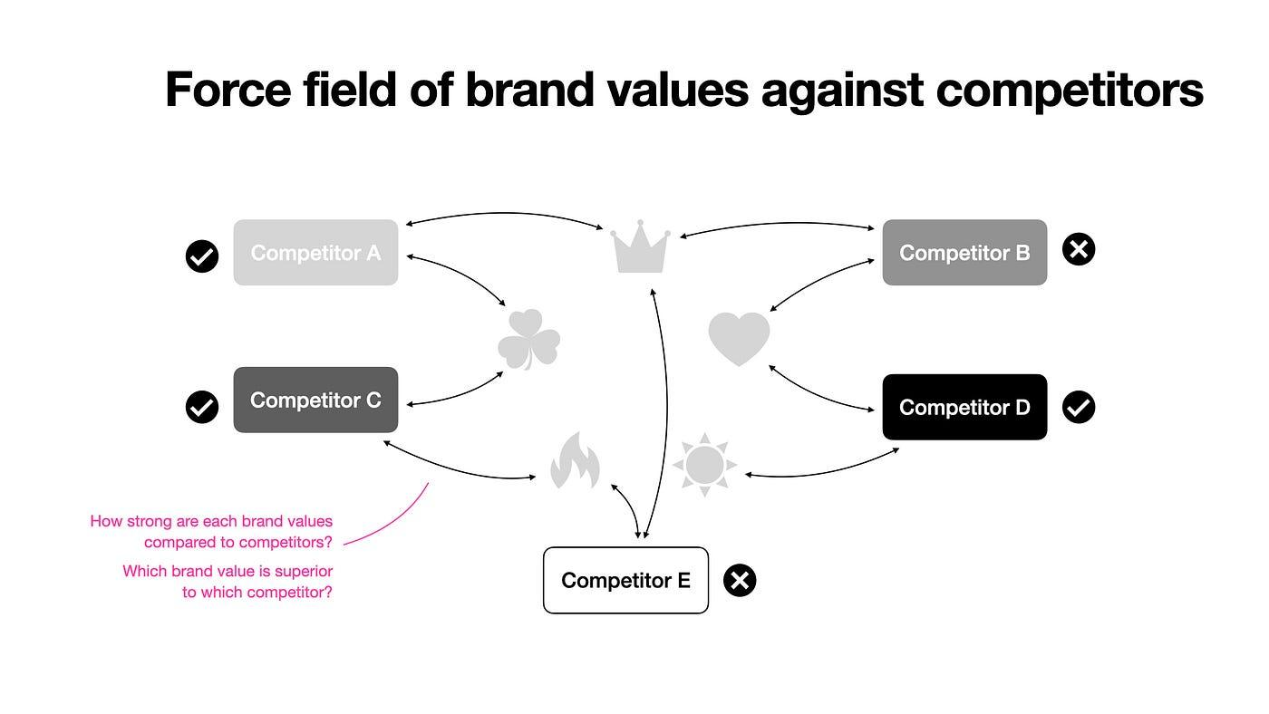
We then conducted a thorough exploration of the brand equity map to determine how it fares against competitors. We began by scrutinizing the portfolios of rival brands and evaluating their product and service offerings, pricing strategies, communication tactics, and sales practices. We then assessed the strengths and weaknesses of the firm in comparison to each competitor, creating a balance of power. Moving on to the next stage, we examined each brand value individually to ascertain the impact of adding or dropping a particular value on the competitive landscape. This exercise helped us to gain a better understanding of the meaning and significance of each brand value.
Armed with a thorough understanding of how each brand value is formed and what role they play, we delved deeper into the wider system and context of the brand values. Our focus then turned to explore the relevant factors at the company, project, and individual levels — everything that plays a role in creating and being impacted by brand values. Through a comprehensive analysis of these factors, we evaluated their impact on the success of the business and identified three critical elements that, if developed meaningfully, can drive significant growth for the brand.
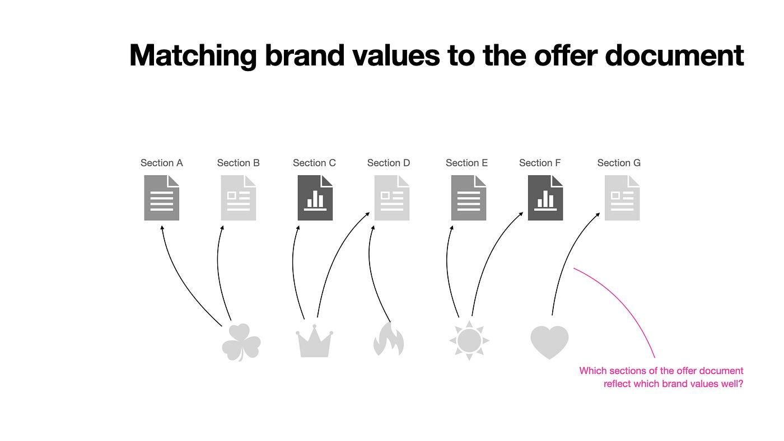
The first factor is the offer document, which serves as a key touchpoint for customers and plays a critical role in shaping their initial perception of the brand. The second factor is personal contact with customers, which creates a unique opportunity to build a personal connection with customers and reinforce the brand’s core values. Finally, the motivation and performance evaluation system of colleagues emerged as a crucial factor in creating a positive work culture that fosters the development of brand values.
These elements not only serve as a catalyst for the brand’s development but also provide a valuable framework for shaping other factors in the future. With this knowledge in hand, we were confident in our ability to help the brand reach new heights, solidifying its position as a key player in the industry.
As part of our comprehensive audit of the offer document, we conducted a detailed analysis of the personal relationships and expectations of the individual stakeholders involved in procurement, taking note of any points of frustration. Using this information, we defined personas and created a stakeholder map, revealing the level of influence each stakeholder has on the procurement process. This approach helped us to identify the key sections of the offer document template that would be critical to the decision-making process and determine if any sections were missing that could facilitate a positive outcome. Drawing on our experience with customer journey mapping, we then identified which brand values would be most relevant at each key section of the document and how they could be effectively integrated. Through this process, we were able to transform the offer document from a functional tool, making it more user-friendly but also a powerful tool for brand building increasing the chances of winning.
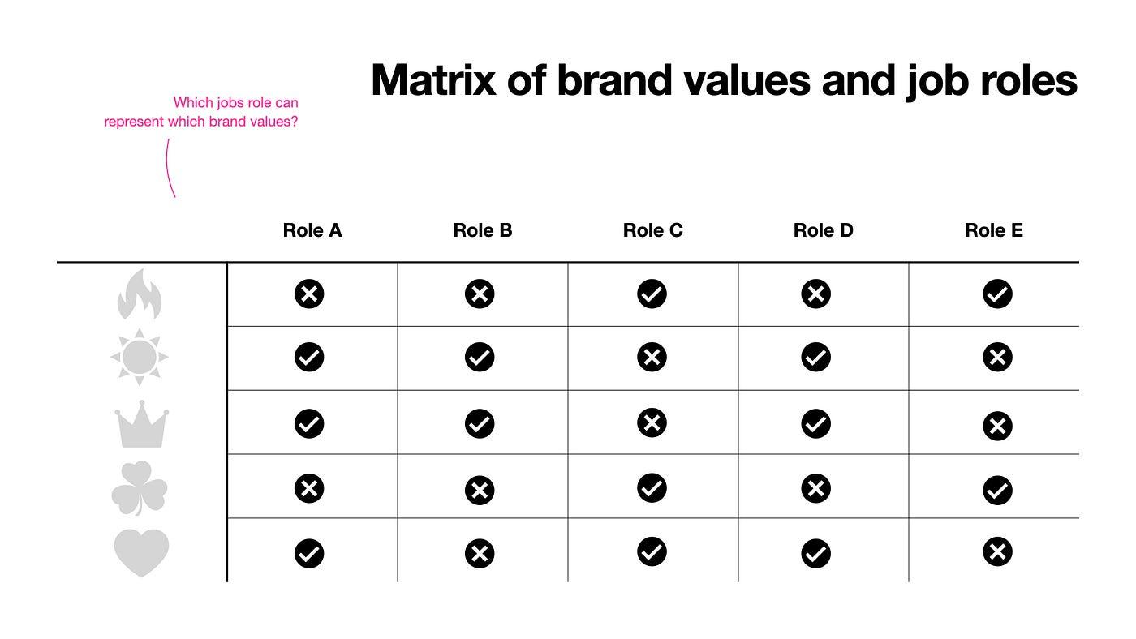
To round out our comprehensive analysis, we turned our attention to the motivational and performance evaluation system, recognizing that personal connections with clients were an essential component of this system. We began by conducting an in-depth interview with the HR manager to gain insight into the company’s current practices regarding motivation and performance evaluation. Drawing on our expertise and knowledge of industry best practices, we then developed a matrix that aligned the company’s job roles with its brand values. By identifying which colleagues in which roles could represent specific brand values during their work, we were able to develop a customized motivation and performance evaluation system for each position. This not only helped to boost employee performance but also ensured that every employee was accountable for representing and building the brand values in their daily work.
In conclusion, creating a well-defined brand requires more than just a communication campaign. It requires a deep understanding of how the brand is formed through interactions with clients and stakeholders, as well as an analysis of the wider system and context in which it operates. By following the process outlined in this case study, businesses can identify and prioritize their core values, align them with their customer journey, and create a unique brand equity that sets them apart from competitors.

The five most important lessons I’ve learned about branding

Two decades worth of experience beyond textbooks and international best practices

The most important lessons about branding are also life lessons
About 25 years ago, I had my first opportunity to get involved in shaping a brand beyond its communication. Since then, I have helped to create nine brands, refreshed and expanded thirteen, and closely followed the development of dozens of others. In that time, I’ve learned and applied countless brand models and philosophies daily to the many agencies and clients I’ve worked for. Additionally, for over four years, I was the local manager of the world’s largest series of category-agnostic brand research, from selecting the surveied brands to finalising questionnaires, and analysing data, and its business application.
All of this provided extensive theoretical and practical experience. However, the most valuable lessons for me were the life situations that aren’t covered in textbooks, brand models, or measurement practices.
It was in these situations that I had to reflect on why we put so much effort into creating brands and what it takes to bring our ideas to life and create value sustainably.
There is nothing sadder or more wasteful than a great brand idea ignored by “business as usual” until it is archived and permanently forgotten.

Lesson one: The term “brand” is often used by different people to mean different things
The first and most important lesson for me was realising that the concept of a brand should not be taken for granted. We can work on a brand for a long time, thinking we all mean the same thing by “brand,” only to realise we were mistaken. A lot of work can be wasted, damaging trust and relationships. The solution is simple: ask at the beginning of each branding project,
“What do we mean by brand, and what role do we want it to play?”
As trivial as it may seem to ask this question, it is essential. Of course, in all this time, I have developed valid answers to these questions.
In theory, a brand is the sum of all the impressions people have of a company, product, or service, and that image is constantly evolving as new impressions are made.
From a business point of view, a brand is the essential difference that keeps people engaged over time.
In practical terms, it is the difference between our promise and our actual performance. I write more about this here.
As much as I was delighted by the simplicity of these definitions, I had to lower my professional arrogance and accept that what counts is what we can agree upon with the people involved, and even more so, what works and helps in the client’s reality.

Lesson two: The context in which brands are created and managed is as important as their content
There is no established brand model or mature brand development process that is one-to-one appropriate for all the situations in which we want to apply it. The personalities, professionalism, and inter-relationships of the people involved in a branding project create a unique force field that, if left unchecked, can wreak havoc with even the most robust tools.
That’s why, as a second step, I draw up a stakeholder map of key players at the beginning of every brand development project.
In this exercise, we list all the actors and factors that may impact the branding project and all those who will be affected by the resulting brand. We identify actors who may influence the creation of the brand through their knowledge, opinions, or decisions, as well as other projects or initiatives that should be taken into account in the development process.
Similarly, there is the question of who will be involved in the management of the brand, who will be affected by it, and how they will be involved in and influenced by. We will then look one by one at what the brand means in the lives of key actors and stakeholders and what they can expect from it.
This exercise, although it may seem unnecessary, especially at the beginning of the project when everyone is eager to brainstorm, is the guarantee that the brand will stick well in the organisation and have a meaningful impact in the long term.
Without this, the brand remains an interesting idea.

Lesson three: Even the greatest brand idea is useless if it does not respond to the business and human needs of its stakeholders
Let’s face it, while some great brand ideas do come out of the mind of a genius, this is the exception rather than the rule. In most cases, brand ideas are the result of diligent and painstaking teamwork, a long gestation process, almost unnoticed. For some reason, it is still more tempting to trust in the spark of the creative genius than in the result of systematic perspiration. But it is important to realise that brands exist for only two reasons.
- On the one hand, the brand owner intends to build and maintain a brand because he hopes to gain financial benefit or some kind of competitive advantage. By branding, he wants to emphasize, attract and make remembered the advantages of his company, product or service. In addition, or even in the absence of this, it adds additional meaning to its product that makes it more attractive to the consumer. He hopes this will result in a price premium and/or lasting customer loyalty.
- On the other hand, brands can also meet basic human needs. We feel we can relate to them. We can find pleasure in them; they can give us a sense of freedom of choice. We can identify with their values, and goals, and experience a sense of belonging. We can define and express our identity through them. They can, therefore, carry the extra meaning we need.
So, as attractive as a brand idea is, if it does not respond to the business need of a company in a way that also reinforces the human need of the people involved, it is really just an attractive idea, nothing more.

Lesson four: Brands are created and evolve in everyday experiences, so consciously designing those experiences is an essential part of brand development and management
The more details I have had the opportunity to look into in my work as a communication agency strategist, the more I have felt a sense of lack. I had a growing desire to understand what else influences the brand image in the minds of consumers, beyond the campaigns and annual communication plans, beyond the agency-managed touchpoints such as brand identity, packaging, in-store presence, website, and brand events. I was looking for what shapes the everyday experiences that can easily override a brand’s intended image.
Initially, I saw UX as this area of expertise, but to the vehement protests of the respective professional managers, I realized that they were looking so closely that ergonomics was indeed the primary goal there. As logical as my reasoning seemed, if all brands strive for the most ergonomic solution, they will inevitably create equally forgettable experiences. And the point of branding would be precisely to consciously plant distinctive memories.
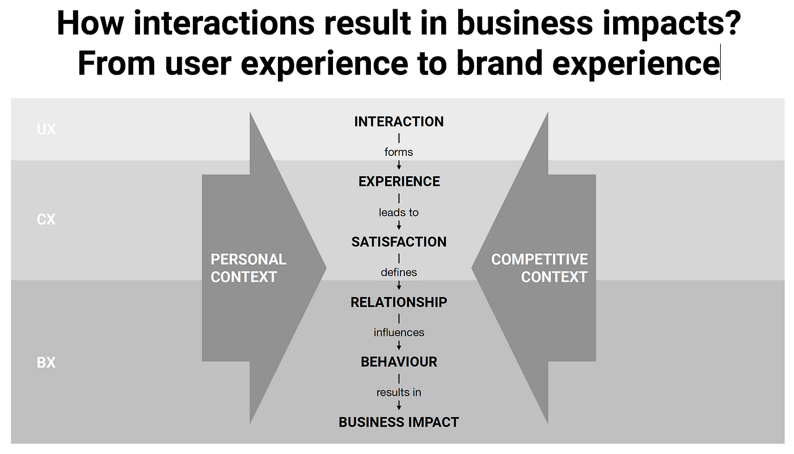
The hierarchy and impact of UX, CX and BX
Later, I had a similar affair with service design. And hospitality design, and consumer and brand experience. In the end, I realised, it doesn’t matter what the framework is, all that matters is that we also consciously address the formative situations in which brand impression is formed as much as it is the result of efforts made with branding intent. As the Heath brothers put it so well in their book The power of moments:
Thinking in moments means recognising where the prose of life needs punctuation.
Great service experience is mostly forgettable and occasionally remarkable. The occasionally remarkable moments shouldn’t be left to chance. They should be planned for, and invested in. They are peaks that should be built. And if we fail to do that, look at what we are left with: mostly forgettable.

Lesson five: The real work begins when the brand is “done”
It took me a long time to understand that when the brand book, validated by research and accepted by all stakeholders, is completed, the real work does not end but begins. This is when the hard work invested into developing the brand will be put into practice. Only in the long term will it become evident if the brand we have created is viable and creates business value. However, the most critical factor is if the organisation can “live” the brand. This means incorporating the brand into daily activities and using it as a benchmark in all possible brand encounters. To achieve this, paying attention to the smallest details is essential. I write about this in more detail here.
Additionally, it is crucial to check in with the brand team regularly to see how things are going, such as after three weeks, three months, and even three years after the work is completed. Although I only recently started to follow this practice, I already see its value. It is an opportunity to reflect, remind ourselves of our original thoughts and intentions, and learn lessons that only time will reveal.
So, I learned, it is only worth spending time and effort on branding if we follow these principles.
What are your life experiences with branding, beyond textbook knowledge and international practice?

Brand / experience / awareness
People are not on this earth to think about brands. Except, of course, for those who do it for a living ;) But even we, the creators and custodians of brands, behave in a very ordinary way in our everyday lives, just like everyone else. We need something to solve a problem, to help us seize an opportunity. We're looking for some kind of utility, something that suits us. When we find our computation, we are happy to return to our choice.
Brands are just images in our heads. Just as our opinions about things in the world in general, our opinions about brands are shaped by two things. The reality of our experiencing selves in a given moment, and the narrating selves that contextualise it through our memories. Research has shown that the narrative self dominates, is far from objective and does not necessarily recall all the relevant stories. Our current impression is therefore an average of a few defining experiences and our most recent experience.
Our perception of brands is also constantly evolving. Whatever impression we have of a brand - whether it comes from the brand's intended activity or in any indirect way - we form our brand image by comparing it with our previous dominant experiences.
There is something else to consider about our impression of brands. Hedonistic adaptation, a natural defence mechanism that helps us to de-emphasise our ongoing experiences. If we keep having the same bad experience, over time we get used to it and it goes away (think of unpleasant smells). The same is true of good experiences. It is not in our nature to enjoy a pleasant experience as much as we did before, so we have to look for new good experiences.
Translated into the world of brands, this means that what surprised us yesterday becomes expected today. What we think is normal today, we'll just gag on tomorrow.
So if we think a brand is what we think it is based on our most memorable and most recent experience - with diminishing enthusiasm - how can we deliver a lasting high brand experience?
As long as our service or product does not answer a real need, there is nothing to talk about. If that is a given, and on top of that we deliver a meaningful difference that there is a customer for, then it's just a matter of delivering some truly stand-out moments in the course of our generally balanced performance.
So our marketing efforts, our promises about the brand, only affect consumer expectations. The moment of truth comes when our promises are fulfilled.
If we over-promise or, if you like, under-deliver, we can change that by improving the product or service, perhaps by reducing our promises, by more realistic communication. Lowering expectations or improving actual experience can rebalance the balance.
The opposite can also happen if we consistently under-promise or over-perform expectations. This positive communication gap is seemingly positive, but it also means that we cannot fully exploit the potential of the product. We cannot win over everyone we might otherwise be able to satisfy. In such cases, our communications need to be improved. To get the goodness in our product across to more people, more convincingly.
Even if we can deliver exactly what we promise, what consumers expect, it is worth working on improving the product. Because of the hedonic adaptation mentioned earlier, even constantly satisfactory performance is in relative deficit. Consumers get used to it and see it as less and less valuable.
Only one question remains. Will our efforts to create a brand experience pay off? Will the impact on the business exceed the investment required to create it? To do this, we first need to select the business variable on which we want to examine the impact of the brand experience. This could be very short-term, like incremental purchase; medium-term, like loyalty; or very long-term, like Customer Lifetime Value. Our independent variable is the customer experience, i.e. the difference between prior expectations and actual experience. From here, it is up to the available data to determine whether we compare values at the individual level of each consumer, matching all encounter points, or whether we measure the impact en masse, narrowed down to a few salient experiences, on a control group.
--------------------------------------------
LIVING
The interaction between a person and his/her environment, which is created within the individual at the moment of action. These experiences are unique to the individual, and the same experience at a different time may give rise to different perceptions.
Experiences are complex in nature, multidimensional (cognitive, sensory, emotional, social and behavioural) and summarise events in different situations.
CONSUMER EXPERIENCE (CX)
The impression that a customer gets directly from a brand, product or service. The reaction that stimuli related to a brand evoke in the customer. The consumer experience takes place throughout the customer's life cycle (finding, understanding, buying, using, leaving) and is always compared with the best of that stage by the consumer, even outside the category. It is from these case-by-case comparisons that satisfaction is born, which is the sum of all experiences across time and touch points that gives the overall consumer experience.
BRAND EXPERIENCE (BX)
Brand experience is not a general perception or perception of a brand. Although it is related to the other elements that make up the brand, it is conceptually distinct from them.
The brand experience is the cumulative result of all customer experiences. It determines, in aggregate, how people value their relationship with the brand. That is, the extent to which the brand has delivered on its promise and met the consumer's prior expectations.
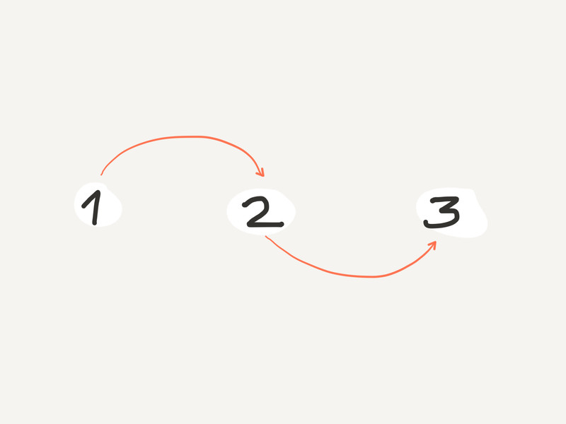
Your branding exercise shouldn't go further than the following three simple steps

Three Steps Branding
Leonardo said it right 'simplicity is the ultimate sophistication'. Following his vision, I try to reduce clutter in branding. Here is the first draft of my new idea of Three Steps Branding. I appreciate any feedback.
Your branding exercise shouldn't go further than the following three simple steps:

Step 1: Find your focus
To pick the only thing you should focus on, look no further, just ask yourself:
a) Is the key attribute of my brand intrinsic or extrinsic? Is it inherent to the product/service (i.e. its ingredients) or loosely connected (i.e. its place of origin)?
b) Is the core value of my brand tangible or intangible? Does it have a direct effect people can physically experience (i.e. taste) or it impacts them only indirectly (i.e. makes them proud)?
What ever is at the intersection of a) the key attribute and b) the core value, will be your focus. Done.

Step 2: Check it from people's perspective
Ask them if they find your focus:
- Believable?
- Meaningful?
- Unique?
Should you get a ‘No’ any of the above, go back to Step 1. and think again.

Step 3: Plan your strategy
Considering that
a) your BRAND = UTILITY x PRESENCE
b) and its MULTIPLIERS = TIME x INVESTMENT x CREATIVITY
you can size up what you already have and where to put your efforts. Where to hope the best return from.
Say your utility is locked and your price is not so competitive. Increase your presence, be more close to your customers. Or if you are new to the market with low a budget, creativity is your weapon.
Can branding be simpler?
I think, it shouldn't.

If brands live out there, in peoples’ minds why we define them from within?
Common wisdom says that a brand is not what marketers are intended it to be, but what people think about it. Still, when we define a brand’s values and its personality we tend to do it from inside out. We use adjectives describing a person. Not what these mean to the people buying or using the given brand. And when researching a brand’s perception we want respondents to do a double abstraction for our own sake: first think about brands as personalities than to do it from the brands’ perspective.
Shouldn’t we turn it upside down? Shouldn’t we define a brand from peoples’ perspective? The people who pay the bill, and whom heads our brand lives in. When wanting our brand to be seen as innovative we should aim for ‘providing ever new ways to serve its customers’. When checking if our brand is seen as trusted we should ask respondents if they rely on it.
The same goal with a different mindset can lead to better results.

